Employee Management
(Created by Sadia Uzma Ashrafi)
Creating database and making the database default
Also created table employee with different columns and its datatypes.
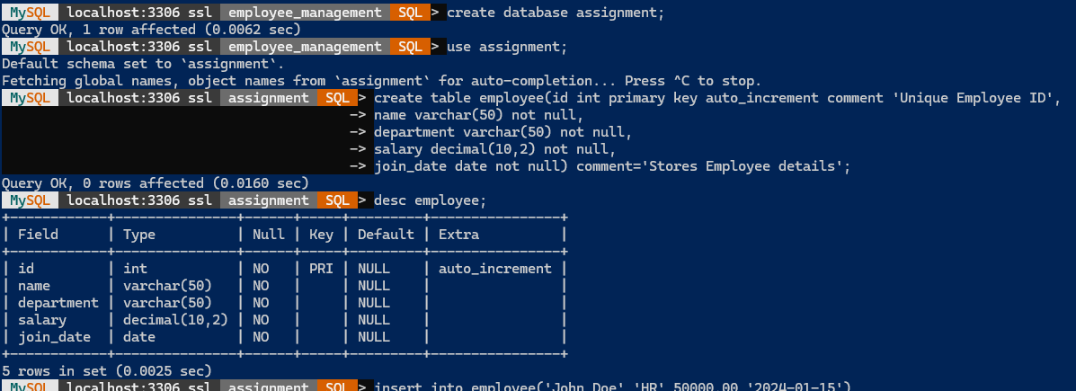
Inserted values into table employee
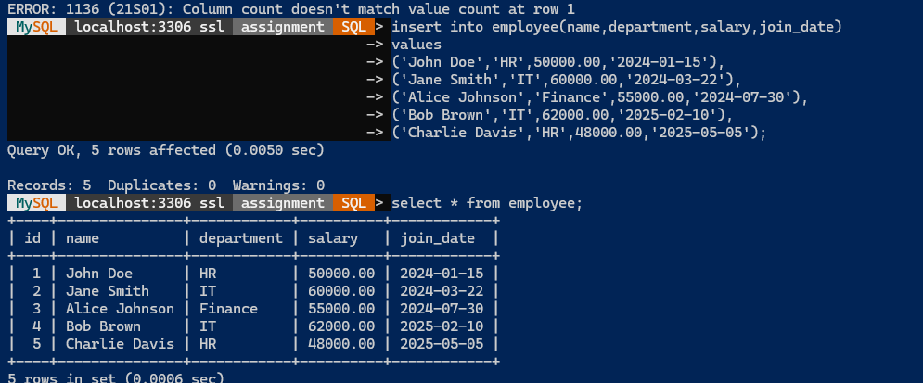
Comment
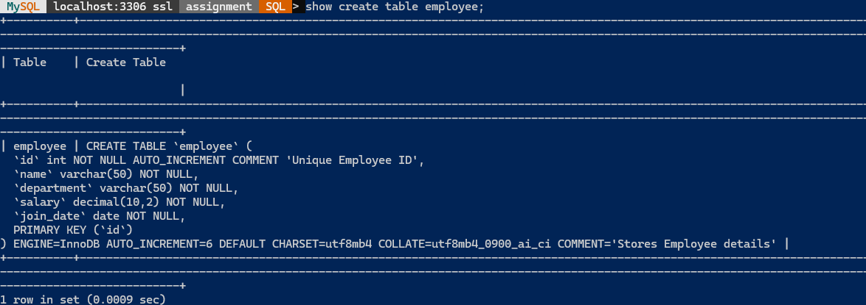

Distinct Departments
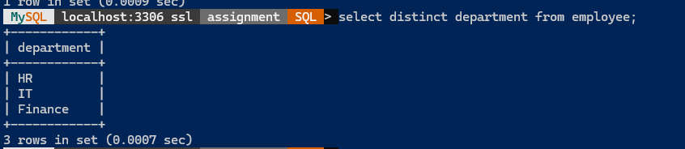
Department IT employees
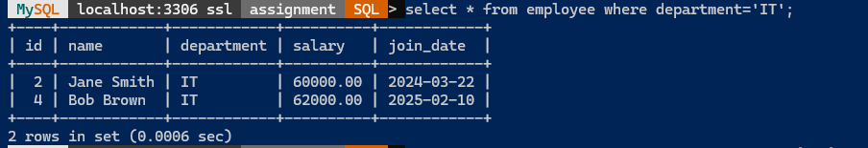
Added another column email
Using limit clause
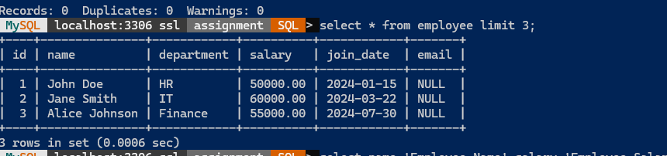
Alias name for columns
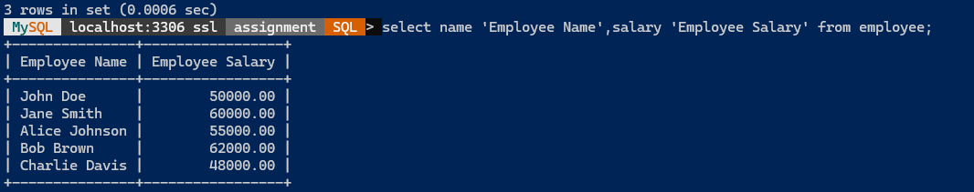

Inserted new row of records
